- Data Flow Diagram

  - Context Level DFD’s

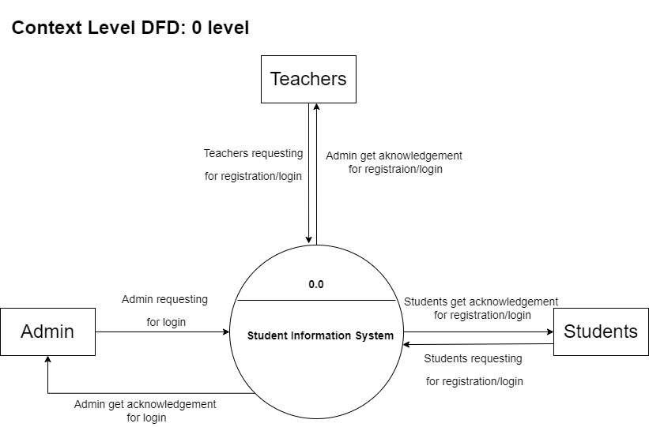
Figure 5.1.1. Context Level DFD: 0 Level

  - Level 1 DFD’s:

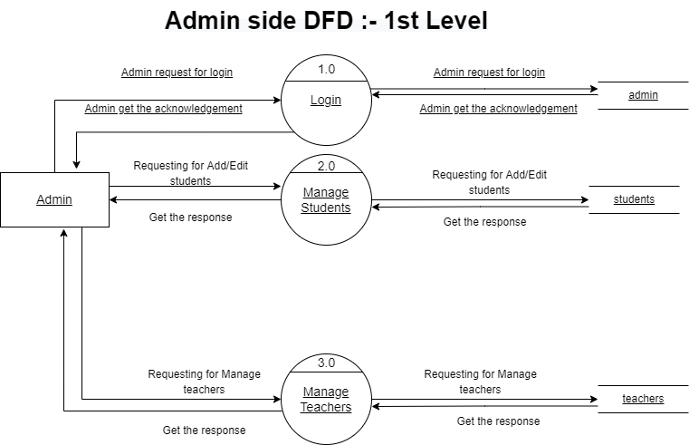
Figure 5.2.1. Admin Side DFD: 1st Level

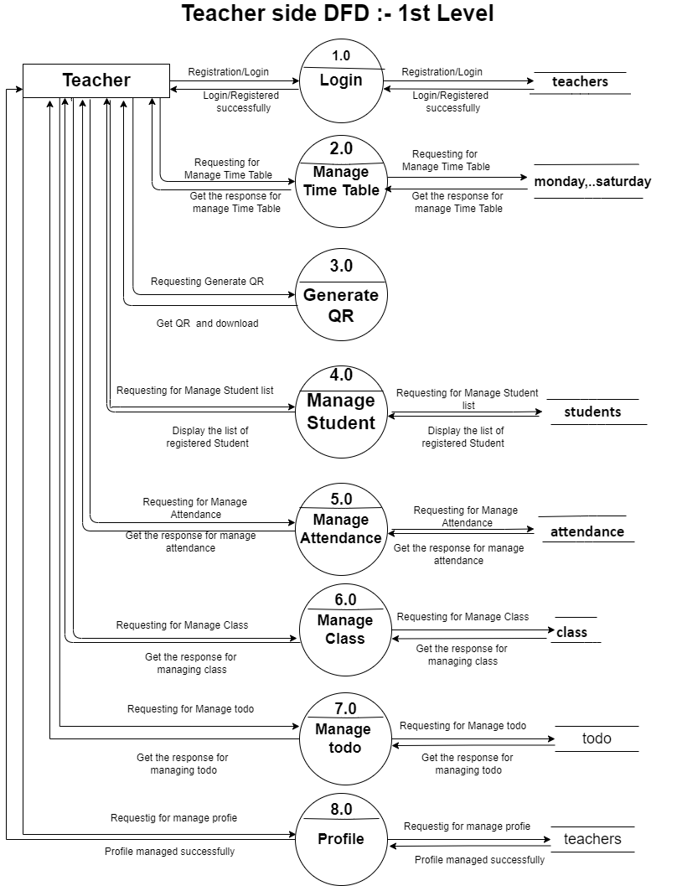
Figure 5.2.2. Teacher Side DFD: 1st Level

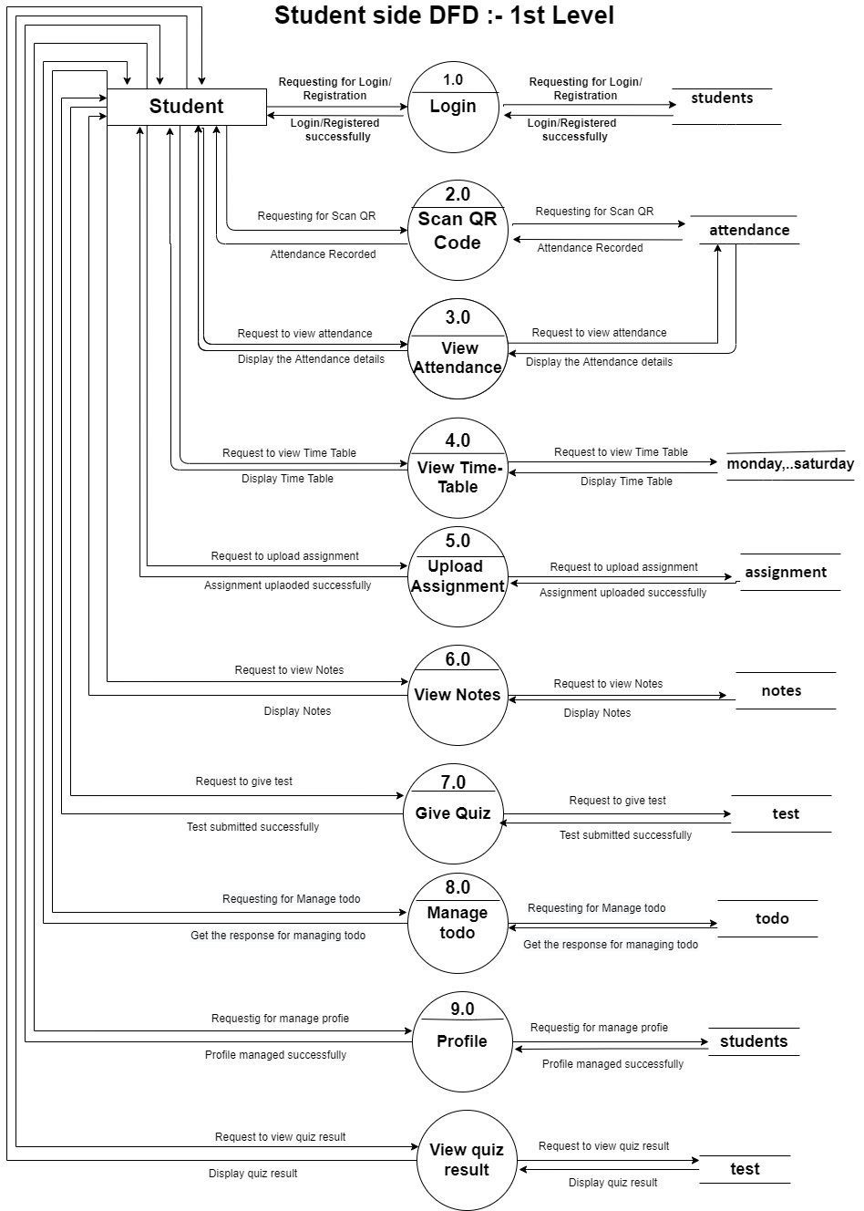
Figure 5.2.3. Student Side DFD: 1st Level
  - Level 2 DFD’s

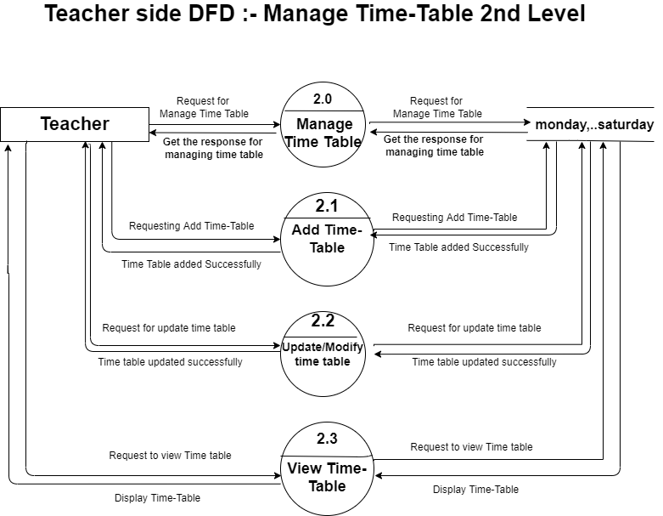
Figure 5.3.1. Teacher Side DFD: Manage Time-Table 2nd Level

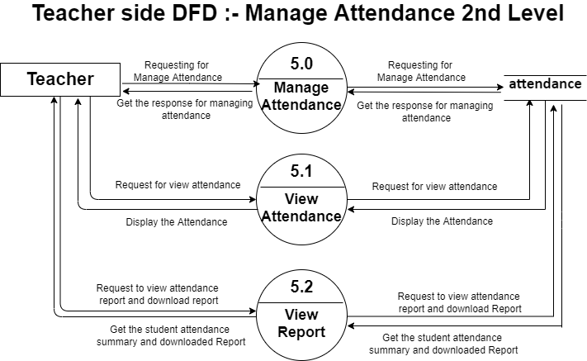
Figure 5.3.2. Teacher Side DFD: Manage Attendance 2nd Level

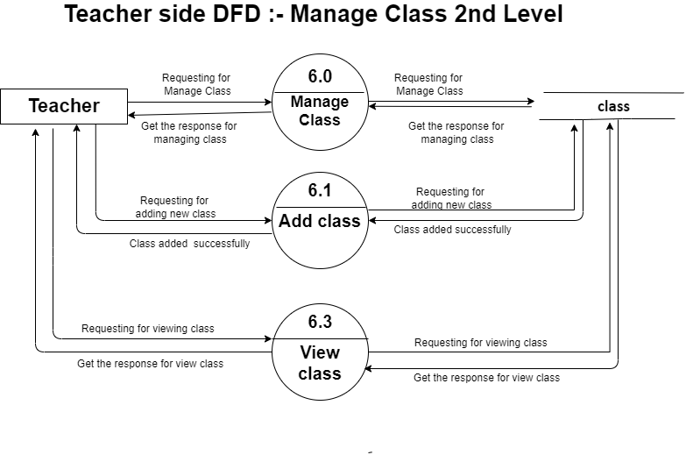 Figure 5.3.3. Teacher Side DFD: Manage Class-Table 2nd Level

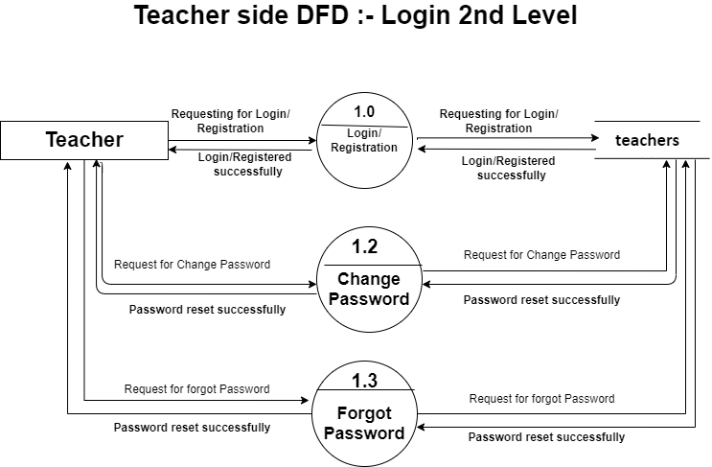
Figure 5.3.4. Teacher Side DFD: Login 2nd Level

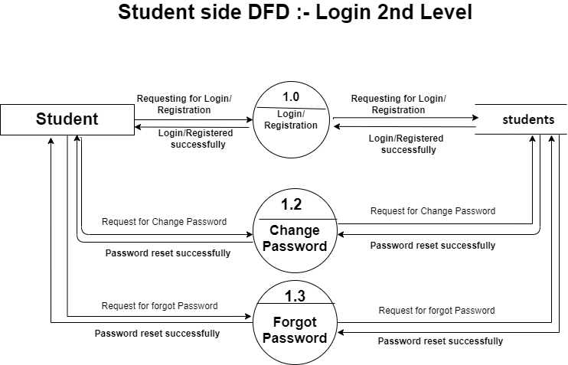
Figure 5.3.5. Student Side DFD: Login 2nd Level

  - Level 3 DFD’s:

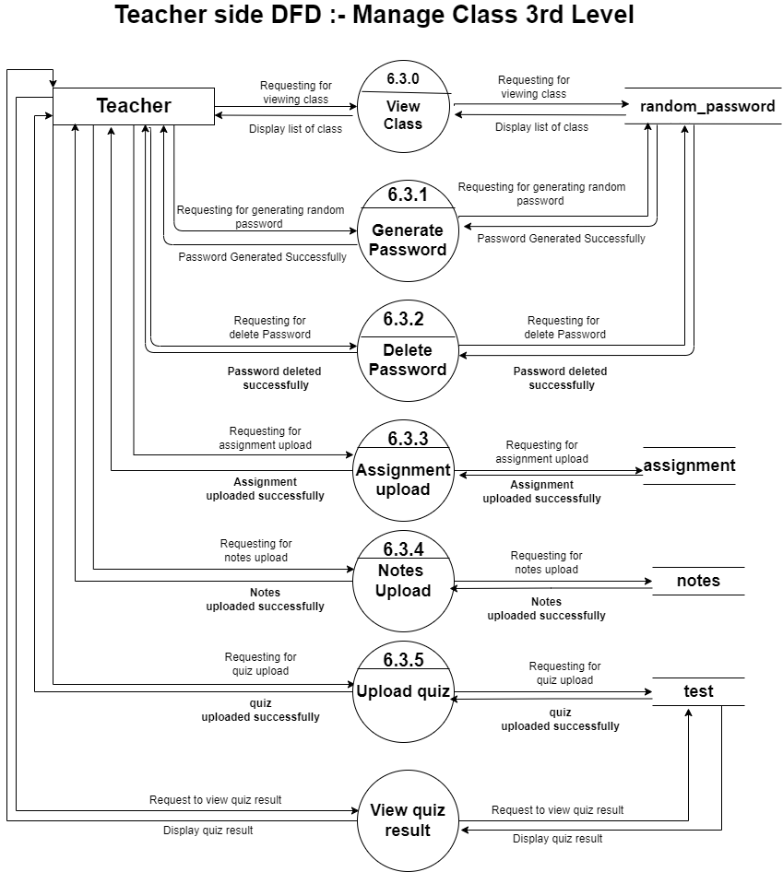
Figure 5.4.1. Teacher Side DFD: Manage Class 3nd Level

- Use Case Diagram

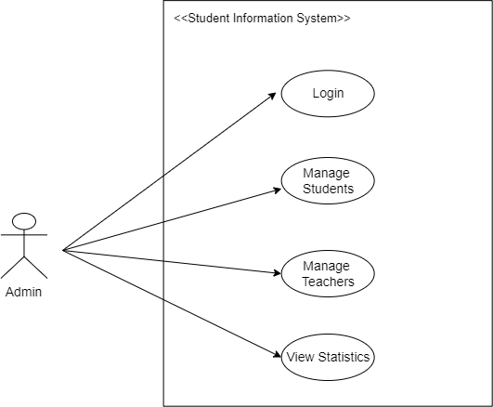
Figure 6.0.1. Admin Use Case Diagram

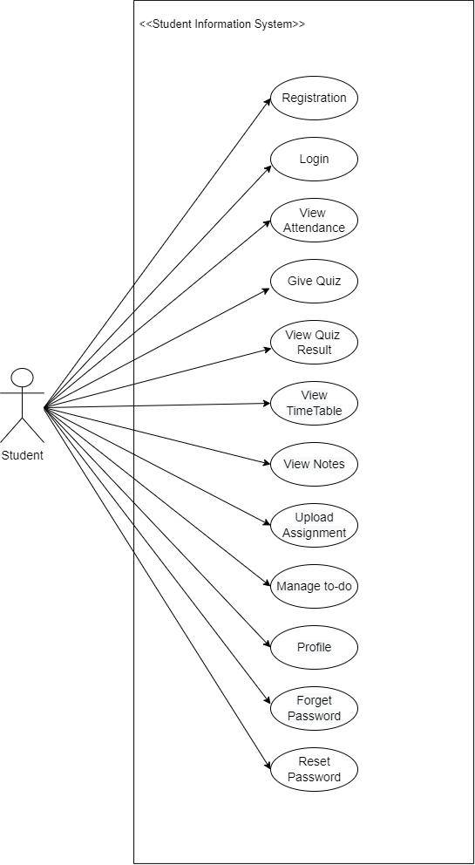
Figure 6.0.2. Student Use Case Diagram
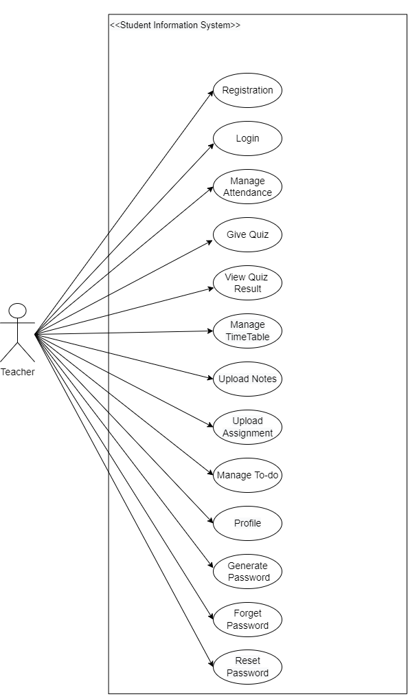
Figure 6.0.3. Teacher Use Case Diagram

- Class Diagram
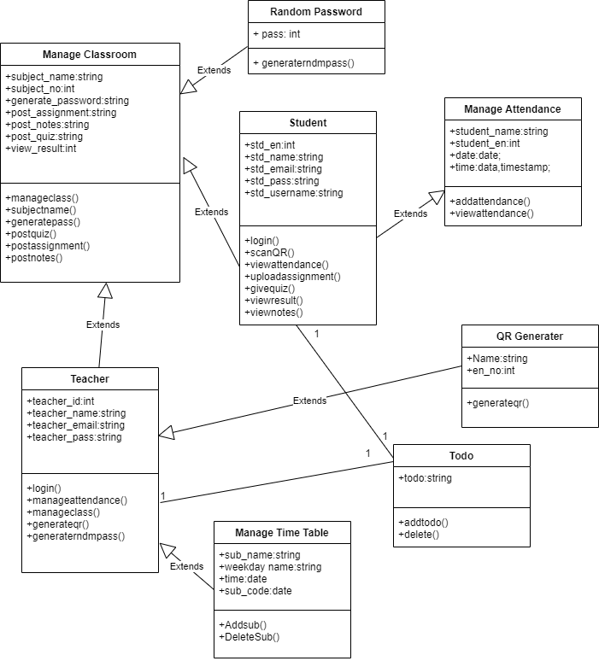
Figure 7.0.1. Class Diagram

- Activity Diagram

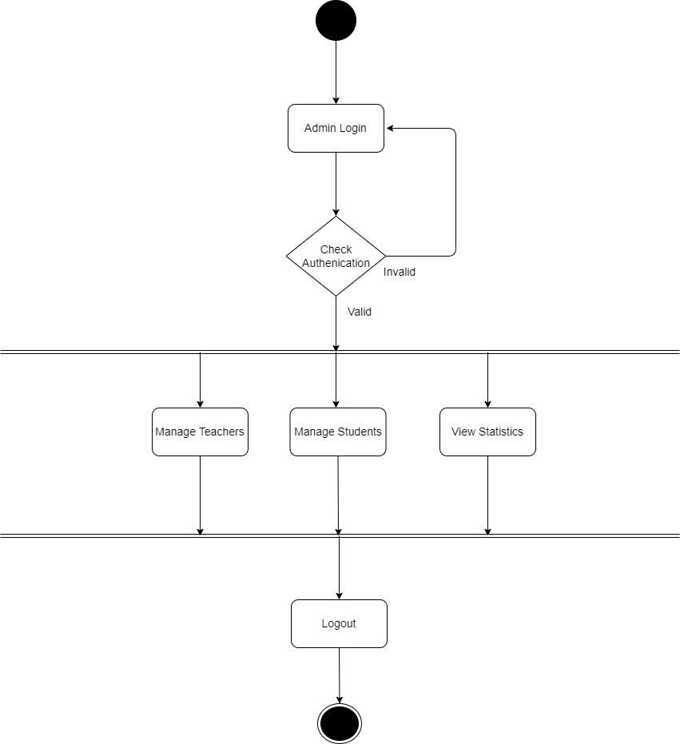
Figure 8.0.1. Admin Activity Diagram

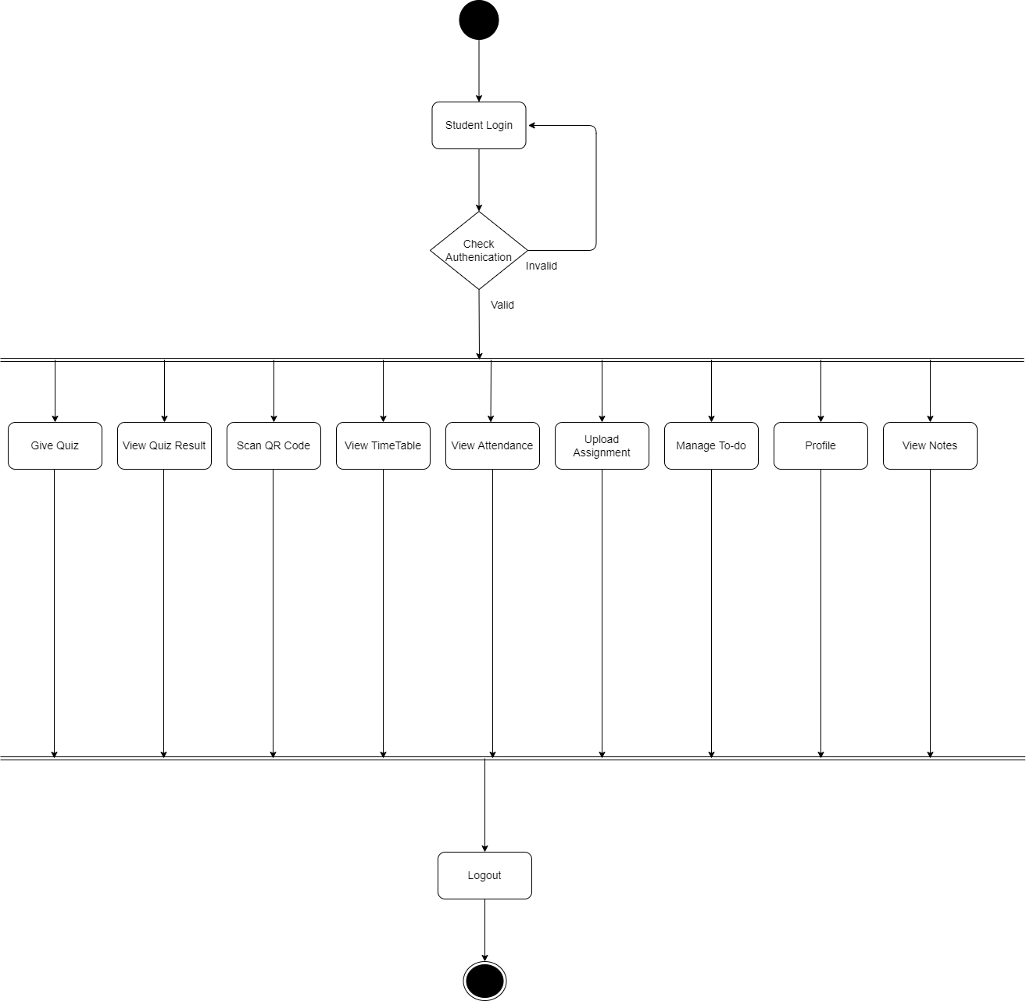
Figure 8.0.2. Student Activity Diagram

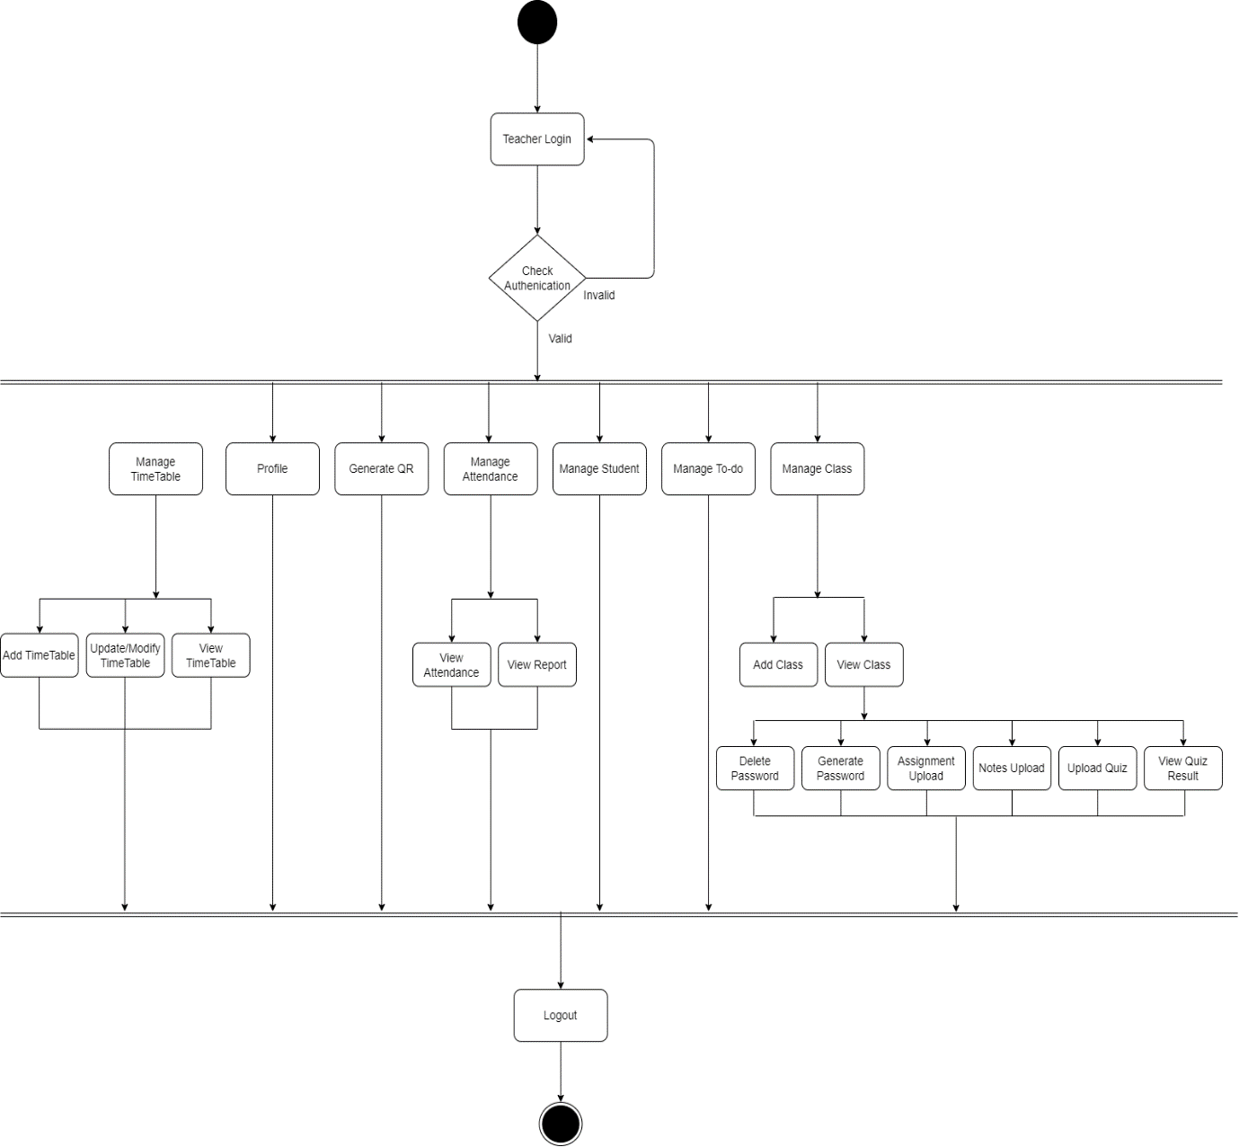
Figure 8.0.3. Teacher Activity Diagram

- E-R Diagram

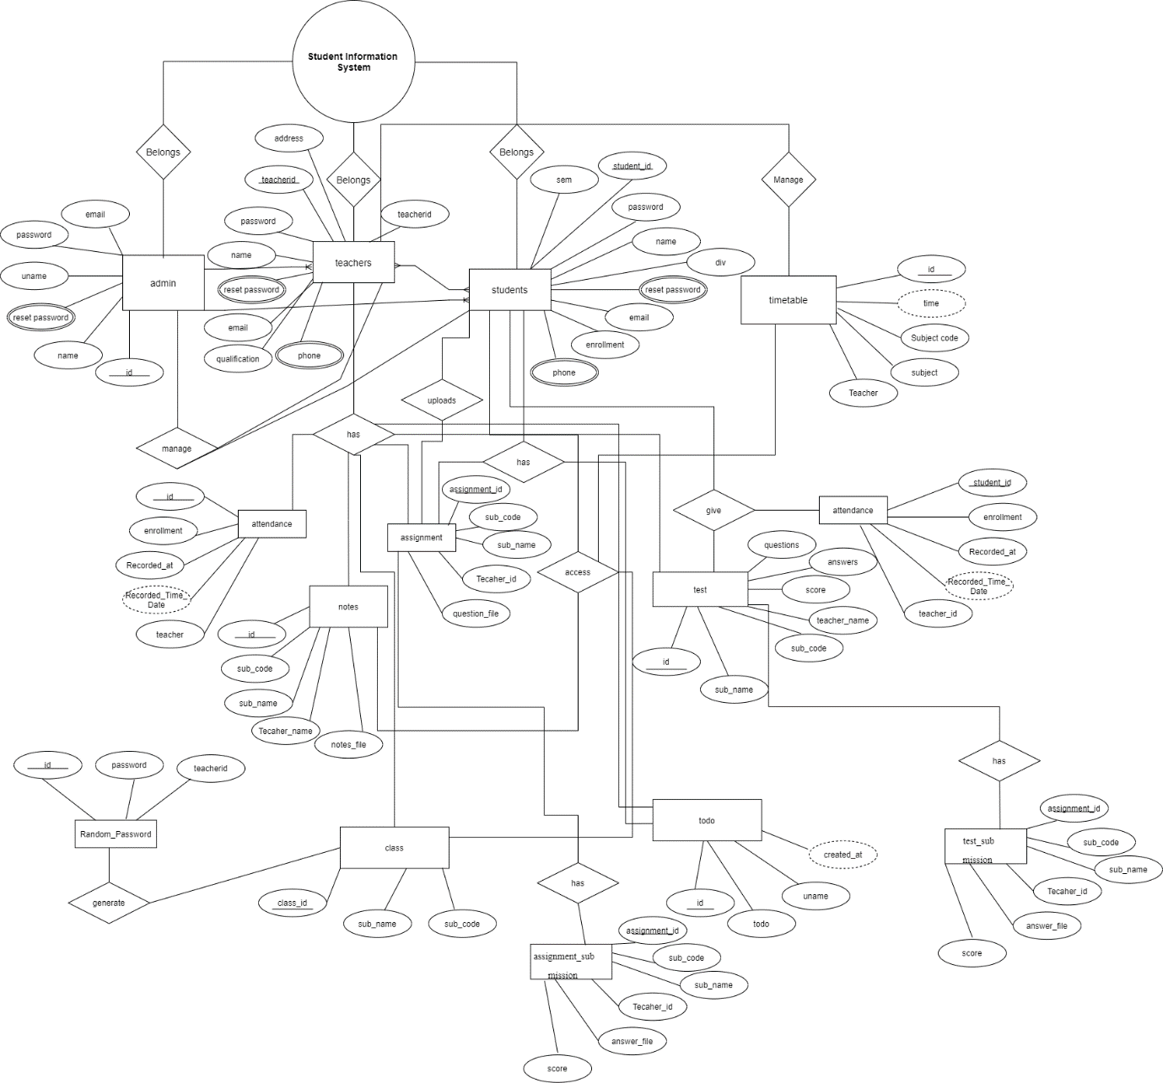

  - Description of E-R Diagram:
This ER (Entity Relationship) Diagram represents the model of Student Information System. The entity-relationship diagram of Student Information System shows all the visual instrument of database tables and the relations between Admin, Teacher, Students, Timetable, Attendance, to-do etc. It used structure data and to define the relationships between structured data groups of Student Information System functionalities.
This ER (Entity Relationship) Diagram represents the model of Student Information System. The entity-relationship diagram of Student Information System shows all the visual instrument of database tables and the relations between Admin, Teacher and Students. It used structure data and to define the relationships between structured data groups of Student Information System functionalities.
The main entities of the Student Information System are Admin, Teacher, Students, Timetable, Attendance, Assignment, Notes, Test, Class, Random_password, Todo etc.
Student Information System belongs to Admin, Teacher and Students entities. In which admin can manage teacher and student’s entities and teacher has attendance, assignments, class, notes, test and todo. In which class can generate random_password. On the other hand students can upload assignment, it has a access on notes, todo and timetable, it can give test and attendance and student entity has assignment and todo list.

